What Is Artificial Intelligence?
Artificial Intelligence Definition – Artificial intelligence, commonly known as AI, is a branch of computer science focused on creating systems capable of performing tasks that normally require human intelligence. The artificial intelligence definition involves the development of algorithms and models that enable machines to learn from data, recognize patterns, and make decisions. This field encompasses various subfields, including machine learning, where systems improve their performance through experience, and natural language processing, which allows machines to understand and generate human language.
Definition:
"It is a branch of computer science by which we can create intelligent machines which can behave like a human, think like humans, and able to make decisions." The main focus of artificial intelligence is towards understanding human behavior and performance. This can be done by creating computers with human-like intelligence and capabilities. This includes natural language processing, facial analysis and robotics. The main applications of AI are in military, healthcare, and computing; however, it’s expected that these applications will start soon and become part of our everyday lives.
This behaviour we may consider from all domains—the human, animal world, and vegetation. A compact definition
of Intelligence is:
Intelligence = Perceive + Analyze + React
This field encompasses various subfields, including machine learning, where systems improve their performance through experience, and natural language processing, which allows machines to understand and generate human language.

The main focus of artificial intelligence is towards understanding human behavior and performance. This can be done by creating computers with human-like intelligence and capabilities. This includes natural language processing, facial analysis and robotics. The main applications of AI are in military, healthcare, and computing; however, it’s expected that these applications will start soon and become part of our everyday lives.

Why Artificial Intelligence?
Before Learning about Artificial Intelligence, we should know that what is the importance of AI and why should we learn it. Following are some main reasons to learn about AI:
- With the help of AI, you can create such software or devices which can solve real-world problems very easily and with accuracy such as health issues, marketing, traffic issues, etc.
- With the help of AI, you can create your personal virtual Assistant, such as Cortana, Google Assistant, Siri, etc.
- With the help of AI, you can build such Robots which can work in an environment where survival of humans can be at risk.
- AI opens a path for other new technologies, new devices, and new Opportunities.

Uses of Artificial Intelligence :
Artificial Intelligence has many practical applications across various industries and domains, including:
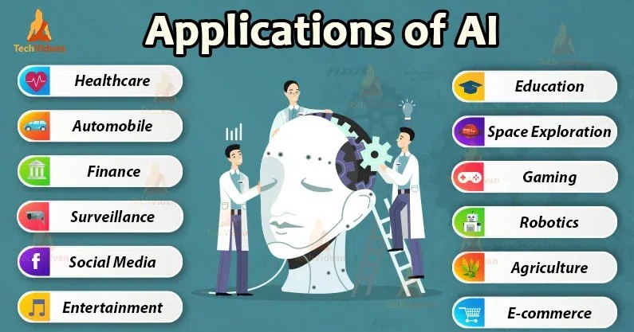

- Healthcare: AI is used for medical diagnosis, drug discovery, and predictive analysis of diseases.
- .
- Finance: AI helps in credit scoring, fraud detection, and financial forecasting.
- Retail: AI is used for product recommendations, price optimization, and supply chain management.
- Manufacturing: AI helps in quality control, predictive maintenance, and production optimization.
- Transportation: AI is used for autonomous vehicles, traffic prediction, and route optimization.
- Customer service: AI-powered chatbots are used for customer support, answering frequently asked questions, and handling simple requests.
- Security: AI is used for facial recognition, intrusion detection, and cybersecurity threat analysis.
- Marketing: AI is used for targeted advertising, customer segmentation, and sentiment analysis.
- Education: AI is used for personalized learning, adaptive testing, and intelligent tutoring systems.

Advantages of Artificial Intelligence
Following are some main advantages of Artificial Intelligence:
- High Accuracy with less errors: AI machines or systems are prone to less errors and high accuracy as it takes decisions as per pre-experience or information.
- High-Speed: AI systems can be of very high-speed and fast-decision making, because of that AI systems can beat a chess champion in the Chess game.
- High reliability: AI machines are highly reliable and can perform the same action multiple times with high accuracy.
- Useful for risky areas: AI machines can be helpful in situations such as defusing a bomb, exploring the ocean floor, where to employ a human can be risky.
- Digital Assistant: AI can be very useful to provide digital assistant to the users such as AI technology is currently used by various E-commerce websites to show the products as per customer requirement.
- Useful as a public utility: AI can be very useful for public utilities such as a self-driving car which can make our journey safer and hassle-free, facial recognition for security purpose, Natural language processing to communicate with the human in human-language, etc.
- Enhanced Security: AI can be very helpful in enhancing security, as It can detect and respond to cyber threats in real time, helping companies protect their data and systems.

Disadvantages of Artificial Intelligence
Every technology has some disadvantages, and thesame goes for Artificial intelligence. Being so advantageous technology still, it has some disadvantages which we need to keep in our mind while creating an AI system. Following are the disadvantages of AI:
- High Cost: The hardware and software requirement of AI is very costly as it requires lots of maintenance to meet current world requirements.
- Can't think out of the box: Even we are making smarter machines with AI, but still they cannot work out of the box, as the robot will only do that work for which they are trained, or programmed.
  - No feelings and emotions: AI machines can be an outstanding performer, but still it does not have the feeling so it cannot make any kind of emotional attachment with human, and may sometime be harmful for users if the proper care is not taken.
  - Increase dependency on machines: With the increment of technology, people are getting more dependent on devices and hence they are losing their mental capabilities.
  - No Original Creativity: As humans are so creative and can imagine some new ideas but still AI machines cannot beat this power of human intelligence and cannot be creative and imaginative.
    - Complexity: Making and keeping AI systems can be very complicated and need a lot of knowledge. This can make it hard for some groups or people to use them.

